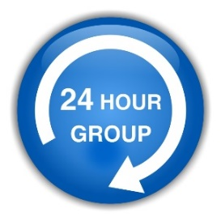
24 Hour Bailiffs Limited
www.24hourbailiffs.com

REMOVAL OF VEHICLES & PERSONS UNKNOWN FROM PRIVATELY OWNED LAND

We hereby authorise and empower you to effect the removal of any unlawful persons and/or vehicles from the privately owned land or premises situated at:
Land/Premises situated and being at:
In the Parish or Borough of : Postcode:
In the County of:
Type of Premises:
No. of Vehicles:
Vehicle Make & Model:
Vehicle Reg. No.: Vehicle Colour:
CONTACT DETAILS OF OWNER, IF KNOWN:
Name of Landlord/Freeholder:
As authorised by:
Name:
Signature:
Address:
Tel No:
And to proceed therein with the removal of all incumbents upon the above land. And for doing this, this shall be your indemnification against all actions at law, as well as against all costs, charges and expenses which you may incur or be liable to pay by reason of you executing this instruction.

Please Note: This information will not be used for any other purposes other than the instructions of the client and will not be passed on to any third party, agent or contractor without your prior written consent.
I confirm that the information provided above is true to the best of my knowledge. I confirm that on instructing 24 Hour Bailiffs Limited. I am agreeing to their terms and conditions and agreed fees, as provided.

SIGNED: ……………………………………………………………………

NAME: ……………………………………………………………………

DATED: …………………………………………………………………….

On completion of this instruction form, please return to 24 Hour Bailiffs Limited by email at info@24hourbailiffs.com Should you have any queries regarding the questionnaire, please do not hesitate to contact us on 01227 750 966 and one of our specialist advisors will be happy to assist you.

